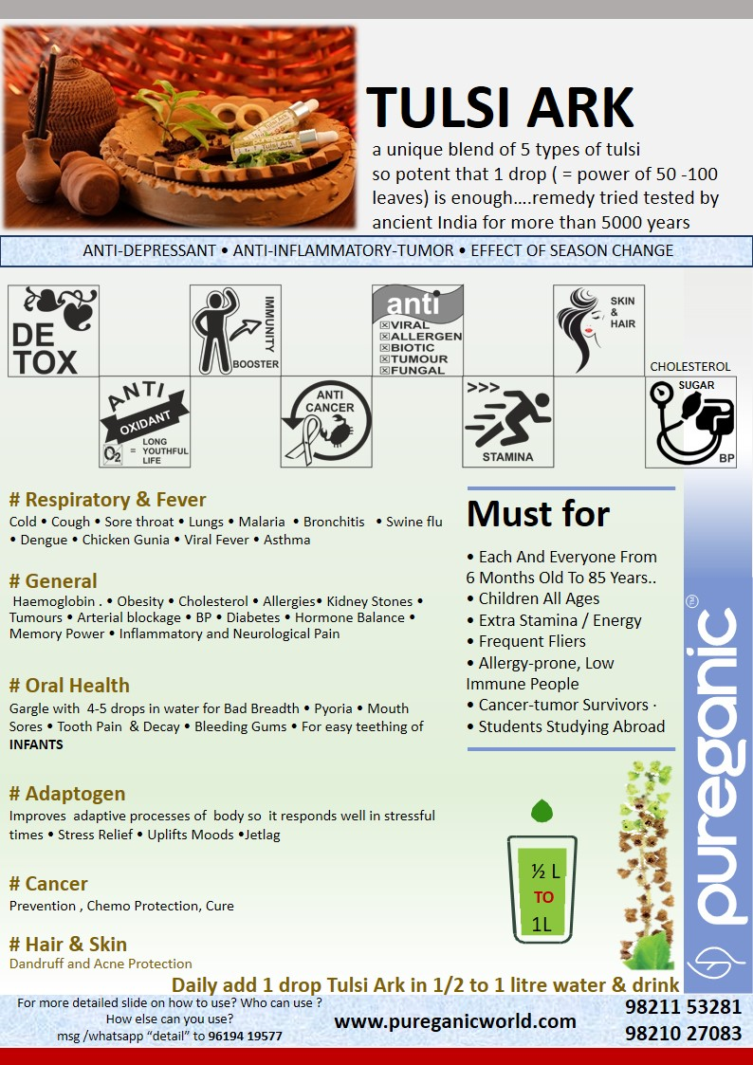
PUREGANIC TULSI ARK FAQ

- What is PUREGANIC TULSI ARK?


  - Tulsi is a Very common herb found in India from the basil group. Due to its exceptional benefits it is considered holy and every household in Ancient India had a bed of tulsi plants
  - It is known to
    - Anti-Oxidant
    - Antibiotic
    - Anti-viral,
    - Anti-cancer
    - Antiseptic
    - Anti-Allergen
    - Anti-Cholesterol
    - Anti-Tumor
    - Anti-Stress
    - Anti-Inflammatory
    - Anti-fungal
  - Ark means essence /extract .
  - Pureganic Tulsi Ark is concentrate of five different varieties of Tulsi
Ram, Shyam (Krishna), Vishnu, Van , Kapur
  - blended in such a proportion that it is healthy and tasty

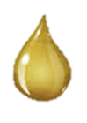

- Why to use PUREGANIC TULSI ARK?

- Detoxifies your body.
- It increases immunity.
- Prevents cold and respiratory problems.
- Tulsi is Adaptogen - a substance that gives an extra boost to body organs and system.
- Its so potent and powerful that just one drop is enough

- I eat fresh tulsi leaves everyday then why must use I use PUREGANIC TULSI ARK?

  - One drop of PUREGANIC TULSI ARK has the power of 50-100 leaves of tulsi.
  - A laser is much more powerful and effective that a tubelight. This is similar analogy.

- Can adults / senior citizens have PUREGANIC TULSI ARK?

  - Yes . Everyone from 6 month old to senior citizen.

- What is the shelf life?

  - This being anti bacterial + anti fungal and also due to the ancient method of making an ark this technically does not spoil for 10 years.

- Can I have more than one drop? Will it cause harm if I have more than a drop?

  - It will not cause any harm if taken more than a drop. But in taste one might find it very concentrated and not so pleasant.
  - In fact in case of high cough, cold or flu we recommend taking one drop twice a day.

- What if I mix PUREGANIC TULSI ARK in single glass instead of half to one liter of water?

  - It will not cause any harm.
  - But in taste one might find it very concentrated and not so pleasant.

- Can I mix PUREGANIC TULSI ARK with green tea?
  - Yes

- Does the water in which I mix PUREGANIC TULSI ARK has to be Warm?

  - Not necessary. Water temperature can be anything even room temperature.
  - In fact it tastes like a wonderful mocktail in slightly chilled water.
  - Only do not cook/heat the ark

- Can I mix PUREGANIC TULSI ARK and PUREGANIC HALDI ARK Together in the same water?

  - Yes You can.

- Can I give PUREGANIC TULSI ARK to infants and children?

- Yes you can.
- For very small children that is below a year give half drop per day.
- That is make tulsi water with 1 drop and then give the child half of that to drink
- To school going children many mothers add in their water bag

- Can I use PUREGANIC TULSI ARK elsewhere beside oral consumption?

- Yes. Read details given below in this PDF under How to Use

- Why is PUREGANIC TULSI ARK called One-drop suraksha chakra?

  - Just One drop is required daily in water, green tea, smoothie, juice
  - It is a daily dose of health and immunity.
  - Gives protection against ailments directly or indirectly by strengthening the organs.

- Why is PUREGANIC TULSI ARK costlier than other tulsi arks in the market?

- No. That is a myth. We are cheaper than other brands.
- Most of the other brands recommend 5 to 15 drops to be consumed per day. They do not have the potency that Pureganic Tulsi Ark has.
- So their bottle may last from one to one and a half month. Where as bottle of Pureganic Tulsi Ark has 180-200 drops so lasts for a minimum of six months. If you calculate per day cost Pureganic Tulsi Ark is not costly at all.
- All the five tulsi that we use do not have the same cost. We use some rare tulsi in larger quantitites which are costly.
- In fact we do not have multiple layers of marketing so compared to the quality that we give we are very reasonably priced.

- Is PUREGANIC TULSI ARK a medicine ?

  - Not medicines, but day to day food stuff.

- How long should I have PUREGANIC TULSI ARK?

  - It detoxifies and immunizes your body so have it everyday - 365 days
  - Pureganic Tulsi Ark is an investment in health.

- I use PUREGANIC TULSI ARK only when I have cough, cold or fever. Is that ok?
  - No. U must have it daily. Continued use will make your body immune so you fall sick less often, effects of season change and allergies are less.

- How is PUREGANIC TULSI ARK beneficial for oral health?
  - Gargle with 4-5 drops in water for bad breath, pyoria, mouth sores, tooth pain, bleeding gums.

How To Use

Daily dose : 1 drop anytime during the entire day
Use daily and not just when u r sick/ill
- Daily add 1 drop PUREGANIC TULSI ARK in half to 1 liter of any temperature water (water quantity depends on personal taste). Consume that water at a stretch in the morning or sip through out the day. Can also mix with curd, green-tea, honey, veg or fruit juice. For children add in their water bottle or in raita or in their cooked food which becomes basil flavoured. Eg: basil flavour pasta.
- mix 3-4 drops PUREGANIC TULSI ARK with Hair Oil / Shampoo for dandruff.
- Mix 3-4 drops PUREGANIC TULSI ARK with facewash/ face pack for acne
- Add 2 drops PUREGANIC TULSI ARK with ½ tsp honey and massage on the gums so that the baby can teeth easily
- Mix 3-4 drops PUREGANIC TULSI ARK with water and apply on face, hands, legs as mosquito repellent
- Add 1-2 drop PUREGANIC TULSI ARK in cotton bud and place on aching tooth
- Add 2 drops PUREGANIC TULSI ARK in half glass water & gargle to remove mouth odour

Must For

- Each and everyone from 6 months old to 85 years..
- CHILDREN all ages
- People facing POLLUTION mobile TV laptop RADIATION
- People needing extra stamina / energy
- FREQUENT FLIERS, allergy-prone, low immune people
- CANCER-TUMOR survivors for preventing relapse
- DIABETICS, BP & CHOLESTEROL
- STUDENTS STUDING ABROAD OR AWAY FROM HOME

PUREGANIC Common FAQ

PUREGANIC SUPERFOODS Common FAQ

- What is meant by NATURAL SUPERFOOD?
- These are some very effective FOODS (not medicines) which were used for centuries by our ancestors because they knew its benefits.
- Our genes are used to these foods and we all are familiar with them and know that these are good for us.
- But in today’s age and fast hectic urban lifestyle it is not easy to procure them in unadulterated, pure, unpreserved form and use daily.
- By natural we mean that we don’t add any chemicals, preservatives, flavours, additives to these products.
- We try to bring them to you with all the goodness and nutrients which nature has instilled.
- This is called superfood because of the miraculous powers of its nutrients to cleanse, immunize and fortify human body.

- Why should we use them?
- This is stuff that helps us maintain GOOD HEALTH.
- We live a fast hectic stressful life
  - surrounded by POLLUTION in air, water, food;
  - RADIATION in Mobile, TV, Laptop;
  - Eat JUNK FOOD full of preservatives
  - Do not eat balanced wholesome food
- Pureganic products help you combat all these problems.
- They DE-TOX, IMMUNIZE AND BUILD HEALTH by providing you with all necessary nutrients.

- For HOW LONG should I take them?
  - This is stuff that empowers your diet.
  - Day-today food just like methi-palak.
  - This is not medicine.
  - This is both preventive and curative.
  - Do not use them like medicine just when you are sick or ill.
  - USE THEM DAILY.
  - This is your INVESTMENT IN HEALTH.

- Are these Ayurvedic Medicines?
- NO. these are NOT MEDICINES but day to day food which from centuries is traditionally used for good health

- WHO can take them?
  - EVERYONE right from 6 month baby to 100 year old senior.
  - Except during Pregnancy or some serious condition take advice from our experts or your own doctor

- How long till I can see the RESULTS or benefits?
- The logic behind PUREGANIC is simple.
  - De-tox - remove toxins or “Kachra” from your body.
  - Immunize - fortify and increase the defence mechanism of your body.
  - Build Health - Nature will take it own course and body will take care of its problems and will heal itself.
- Its like servicing your AC. The technician cleans it, fortifies it and it functions better.
- Though results vary from person to person, generally with in a week you see little –little improvements and over a period of couple of months you feel marked difference not only in your problems but also over all stamina and vigor (“sfurti”).
- Since the herbs are pure and potent many people feel a marked difference right from first dose.

- Will it INTERFERE with any OTHER MEDICINE that I am Taking?
  - NO. As this is like normal food there are no side effects and is not harmful in any way.
  - You can continue taking your other medicine just like you used to
  - Our experience has been that as your health improves automatically your physician reduces the dose or stops external medicines.

- What is an ARK? What are ITS ADVANTAGES?
- Ark means extract or concentrate.
- It is an ancient Indian Concept where we capture the essence of any thing keeping all its properties intact.
- Herbal arks are very potent, powerful and hence very very effective.

- Can I MIX any two Arks?
  - Yes.

- HOW should we CONSUME?
  - Arks are very very concentrated extracts and can be consumed AT ANY TIME of the day.
  - Powders like Wheatgrass, Moringa or Purecolo are recommended on empty stomach consumed with 2 glasses of water/ fluid and no food intake of 10-15 mins after consumption. This helps better absorption and so more effective results.
  - On our website we have detailed information of method of consumption. But please feel free to call our Customer Care in case of any doubts.

- What are the SIDE-EFFECTS?
  - Since these are natural herbs just like parsley or methi without chemicals or preservatives they have NO SIDE EFFECTS.
  - If any doubt or problems encountered while consumption please contact us and we will tell you solutions or alternatives.

- Can I give to SMALL CHILDREN?
- Yes. In fact we try to make all our products CHILD-FRIENDLY.
- We feel that adults may compromise on taste or bear discomforts for health but children will not do so.
- Fortifying their health helps in their growth and builds a strong foundation for future health and disease prevention.
- Our products can be given to INFANTS as well. They are very safe. In case of infants it is advisable to dilute the normal dose a little.

- Are Your products BITTER LIKE MOST OF AYURVEDIC STUFF?
  - No. We try to ensure that they are very tasty and refreshing.
  - Our motto is TASTE BHI HEALTH BHI.
  - All our products except Moringa Powder are Yummy and children love them.

- Are they PREVENTIVE OR CURATIVE?
  - Both.

- Can I COSUME AND APPLY EXTERNALLY?
  - YES products like Tulsi Ark, Haldi Ark, Brahmi Nasya, Moringa Oil, Purecolo can definitely be applied externally as well as consumed internally for maximised results.

- What IF I FACE CERTAIN PROBLEMS while consuming?
  - Our preferred methods of consumption are designed for maximised benefits but some people may not have understood correctly or sometimes there is a genuine problem.
  - CALL US ON CUSTOMER CARE we will understand your problem and suggest suitable ALTERNATIVE METHODS OF CONSUMPTION.
  - Such alternatives might be less beneficial then preferred methods but we believe “something is better than nothing”.

- What is UNIQUE about PUREGANIC SUPERFOODS?
Some products like Brahmi Nasya, Herbi GUD, IRONSHAKTI WE ARE THE ONLY / FIRST ONES IN INDIA to make them
We are farmers ourselves and understand plus control raw material from basic
These products are
- perfect fusion of traditional knowledge and modern techniques so we call it
- “ANCIENT FOOD FOR MODERN TIMES”
- aiming at shifting people from “PHARMA”CEUTICAL to “FARMA”CEUTICAL
- Tasty, YUMMY and convenient to use
- Good for all ages so Everyone from the family can use
- Safe and without side-effects
- Preventive and curative

- Why do you recommend so many products for one particular problem / disease?
  - Generally in any medicine multiple drugs are added and combined to give desired results.
  - These drugs are formulated from processed chemicals and herbs and then fused into one tablet.
  - Since we are keeping the herbs in their natural pure form with minimal processing (to ensure there no adverse side effects) we recommend multiple herbs

Please note : All claims based on traditional Indian knowledge

